Demo of React.js

(without installing software on computer)

--- Cherita Lashley, JAVA Bootcamp, 2/13/17 ---

1. In Browser Type codepen.com

Codepen.com

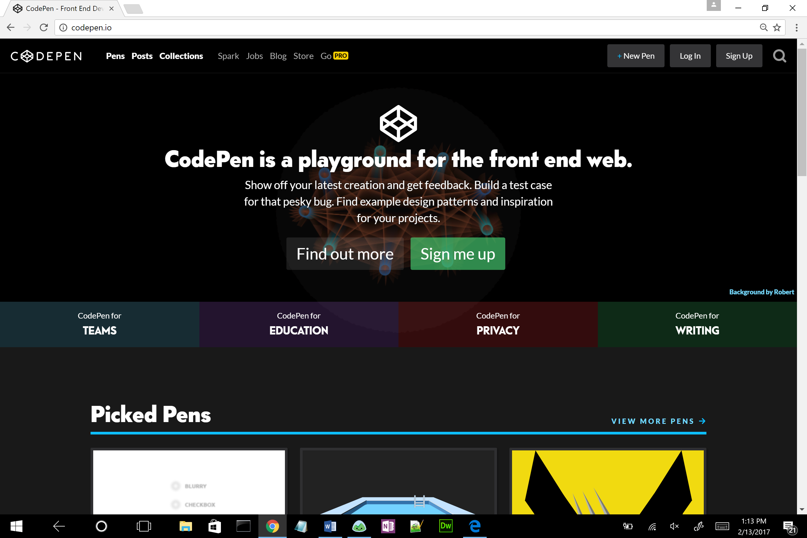

New Pen

2) Click New Pen at the top

3) Change Settings

* Click on Settings
* Click on CSS - Click on SCSS
* Click on JavaScript – Click on Preprocessor, and Change to Babel
* Add link for External JavaScript - //cdnjs.cloudflare.com/ajax/libs/react/0.13.0/react.min.js
* Click Close

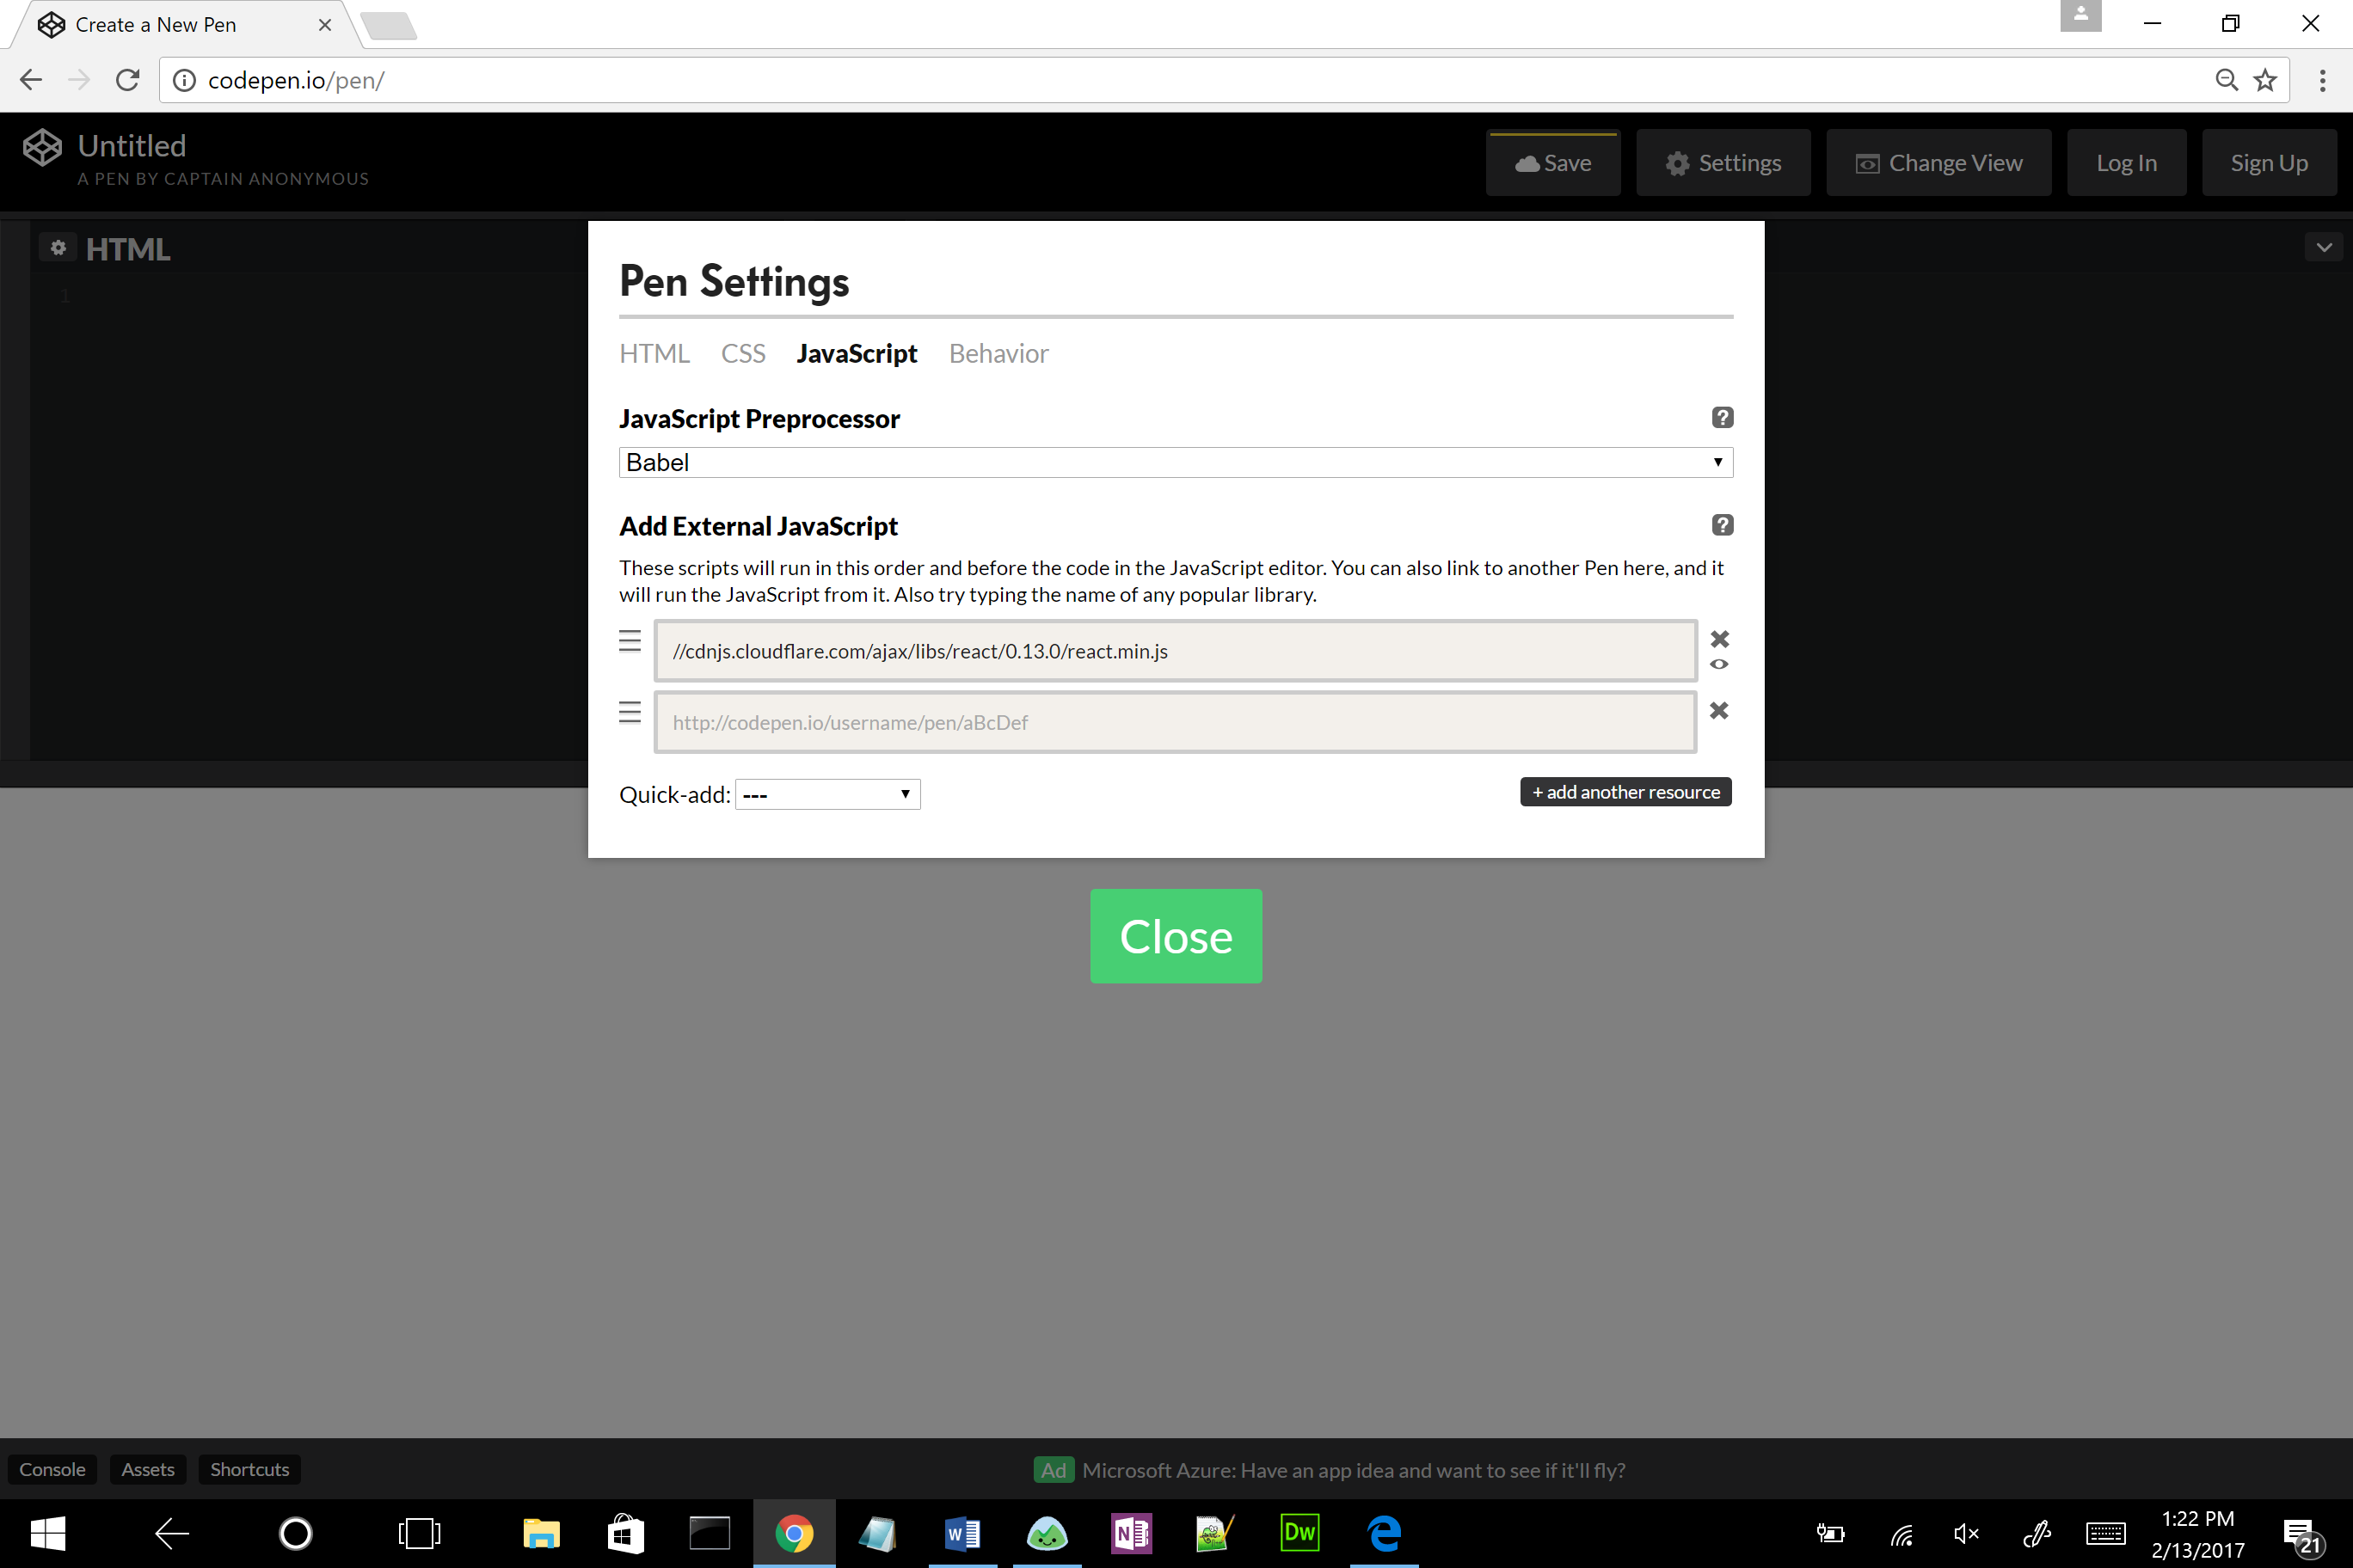

//cdnjs.cloudflare.com/ajax/libs/react/0.13.0/react.min.js

4)Reduce the CSS Screen size by using your arrow keys in the middle of screen

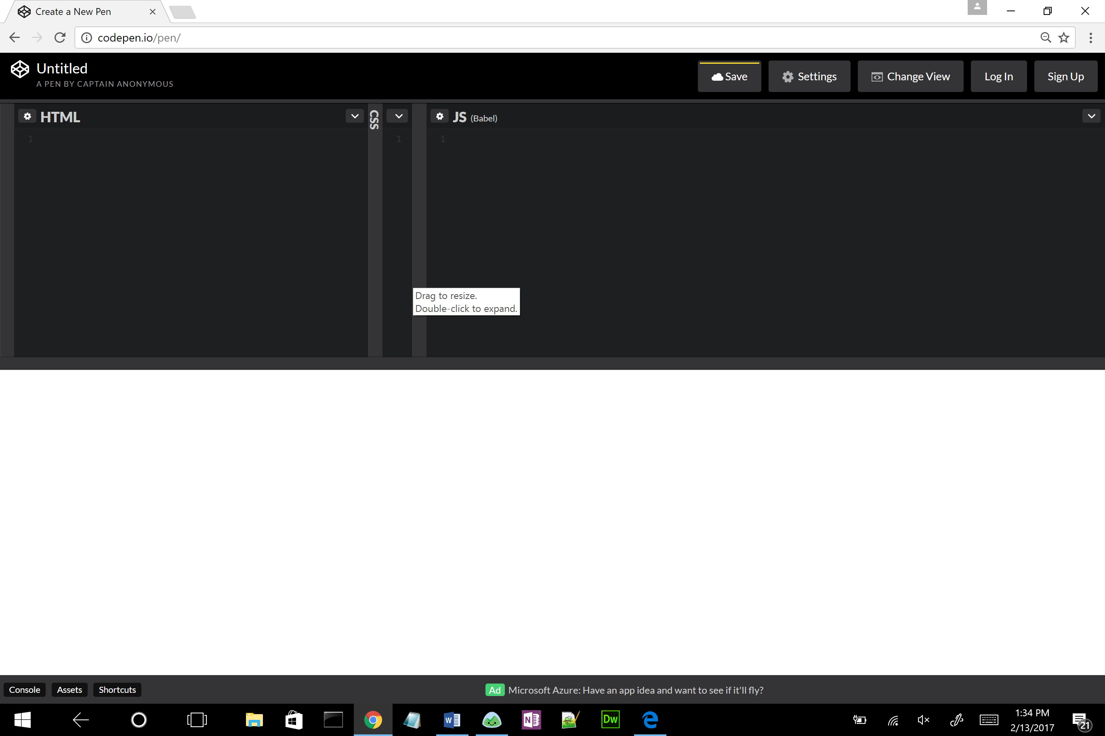

class Profile extends React.Component{

render(){

return <h2> HELLO WORLD </h2>

}

}

5) Create a class called – class Profile extends React.Component { } in the JS screen

6) Create a method called render() {return <h2> HELLO WORLD </h2>; }

This will allow your html code to write the code

7) Add a container <div> tag to the HTML screen

<div id="app"></div>

8) To the JS screen add a React component to allow the render method to be printed

React.render(<Profile />, document.getElementById(‘app’));

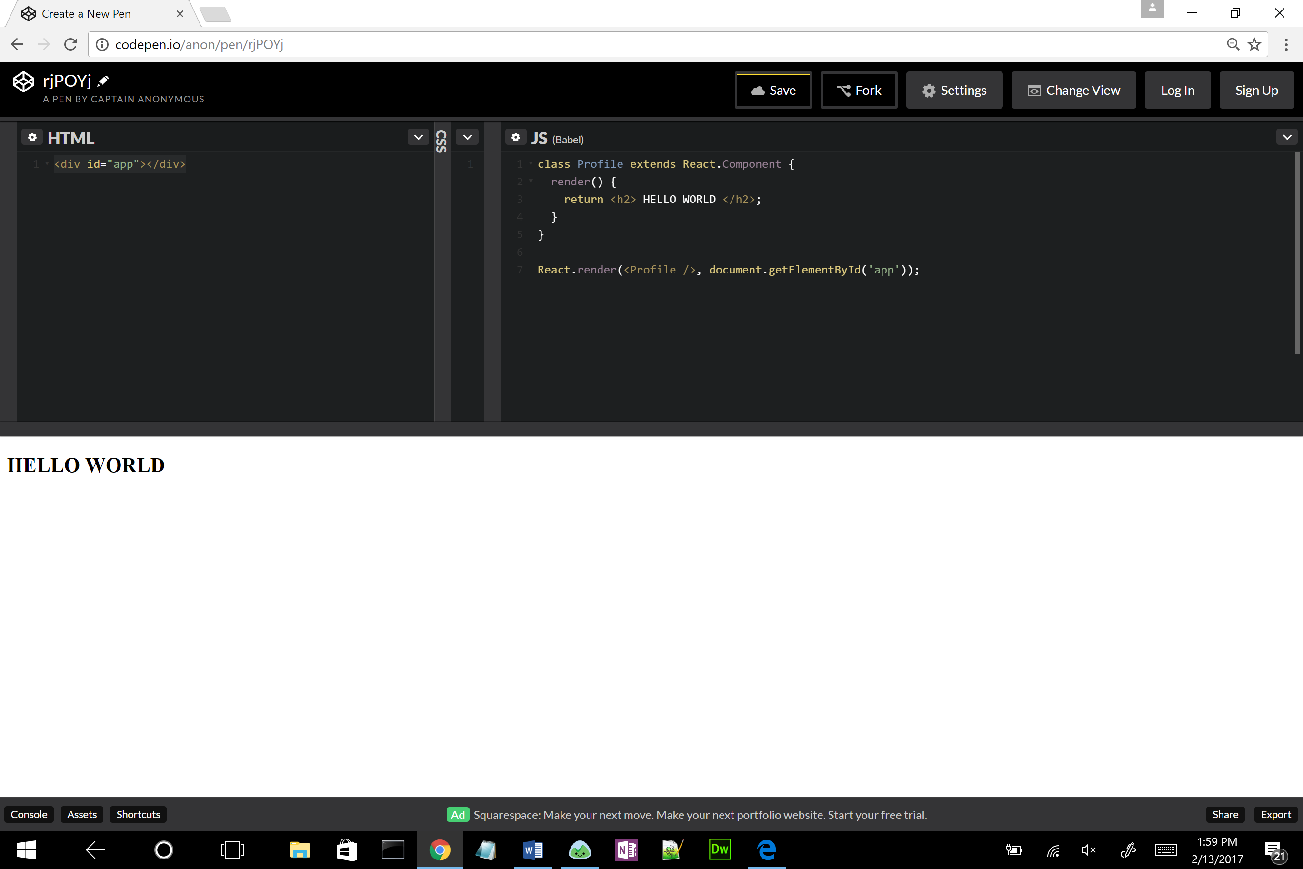

class Profile extends React.Component{

render(){

return <h2> HELLO WORLD </h2>

}

}

React.render(<Profile />, document.getElementById("app"));

9) To write multiple lines you have to enclose the HTML component within ( ) and a <div> tag

Change code to display the following lines:

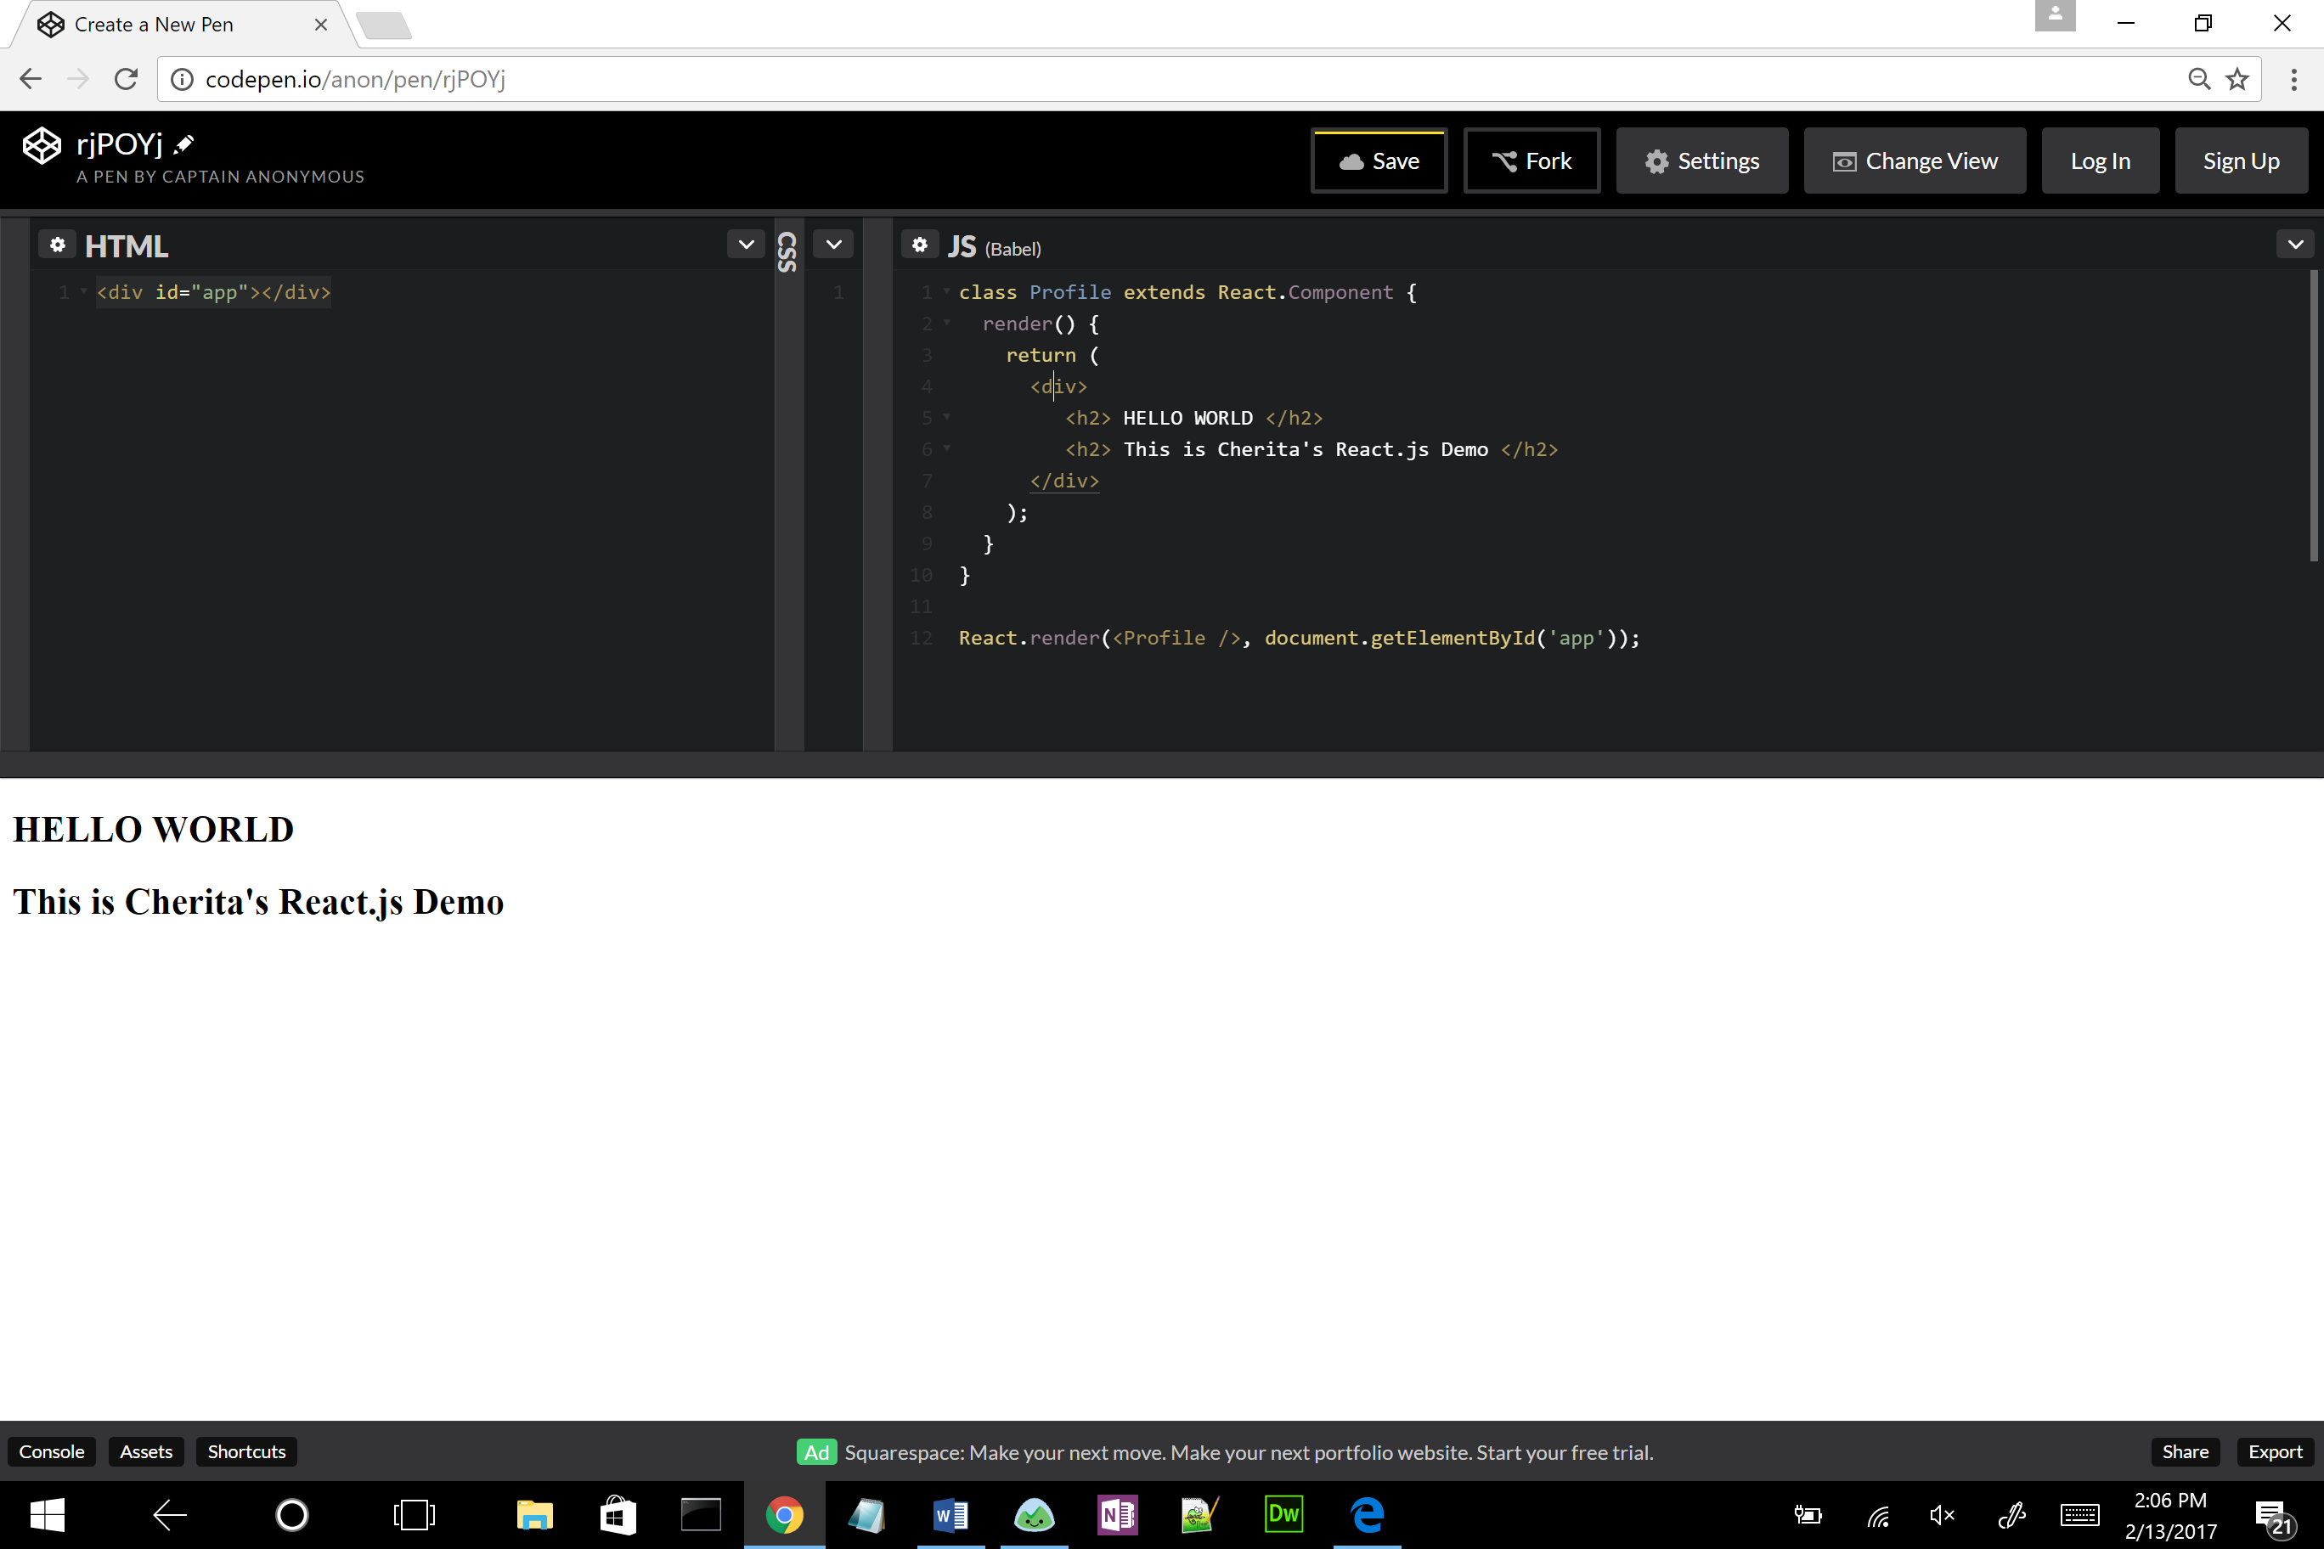

return (

<div>

<h2> HELLO WORLD </h2>

<h2> This is Cherita's React.js demo</h2>

</div>

);

}

}

10) To pass data into the Class you have to use this thing called Props

Change the React.render line at the bottom to look like the following:

React.render(<Profile name="Cherita Lashley" age={30} bio="I like REACT JS."/>, document.getElementById('app'));

Make sure you use your name, your age, and something you like inside the bio.

11) Change the Hello World to the following to use the Profile info:

<div>

<h2> Name: {this.props.name} </h2>

<h2> Age: {this.props.age}</h2>

<h2> Bio: {this.props.bio}</h2>

</div>

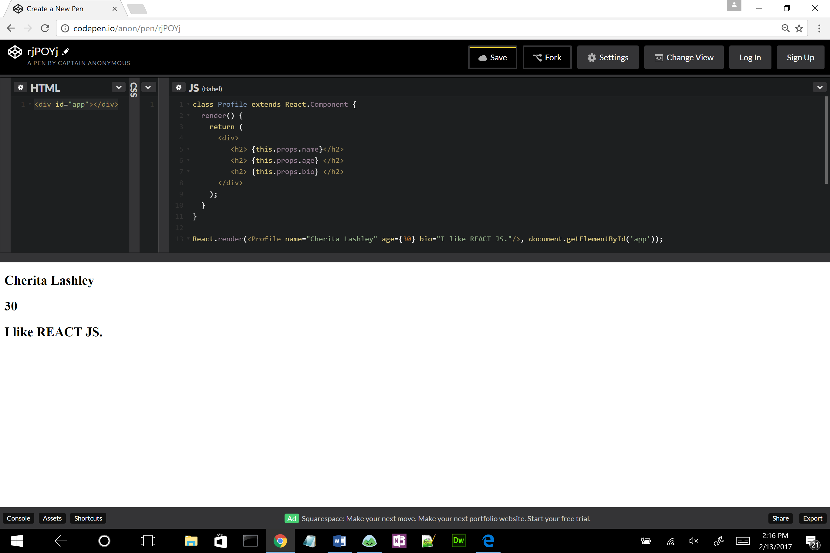

12) There is a lot of repeating code so to clean it up a little bit, we can do the following:

This is known as destructing, this will find the objects and pull out the values, so it will return the same info.

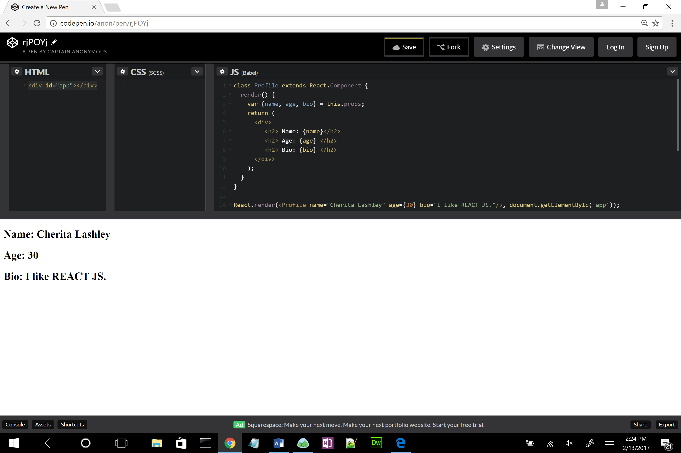

class Profile extends React.Component{

render(){

var {name, age, bio} = this.props;

return (

<div className="profile-box">

<h2> Name: {name} </h2>

<h2> Age: {age}</h2>

<h2> Bio: {bio}</h2>

</div>

);

}

}

React.render(<Profile name="Cherita Lashley" age={24} bio="I like REACT JS."/>, document.getElementById("app"));

13) Expand the CSS Screen size by using your arrow keys in the middle of screen. To use CSS styles, you have to tell the system that this class is a CSS class by using the words “className” like the following code:

<div className=”profile-box”>

14) Add a CSS class called “.profile-box”. Type the following in the middle to add a box around your profile info.

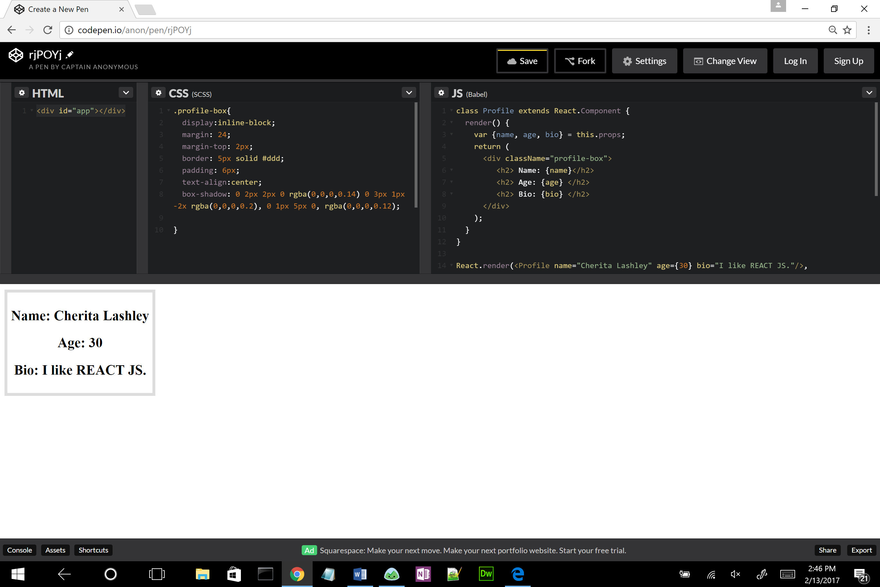

.profile-box{

display: inline-block;

margin:24;

margin-top: 2px;

border: 5px solid #ddd;

padding:6px;

text-align:center;

box-shadow: 0 2px 2px 0 rgba(0,0,0,0.14), 0 3px 1px 2px rgba(0,0,0,0.2), 0 1px 5px 0, rgba(0,0,0,0.12);

}

15) I hope you liked learning a little about React.js. There is so much more to learn. Happy coding!